Multi Turn AI using LLama3
Software Requirements Specification

Version 1.0



Group Id: S26PROJECTCA4A9
Supervisor Name: Neelam Alam

Revision History
Date (dd/mm/yyyy) | Version | Description | Author
00/0/2026 | 1.0 | The Multi-Turn AI Chatbot with Llama 3 is an AI-based conversational system that allows users to engage in continuous and intelligent conversations across multiple domains. The system uses the Llama 3 model to generate real-time responses and manages conversation context for better interaction quality. It includes secure Google OAuth login, session management, mandatory feedback collection, and real-time data storage, the project provides analytical dashboards with graphs and reports to evaluate chatbot performance, response accuracy, and user feedback. | BC230201330

Table of Contents

- Scope (of the project)
- Functional Requirements Non Functional requirements
- Use Case Diagram
- Usage Scenarios
- Adopted Methodology
- Work Plan (Use MS Project to create Schedule/Work Plan)

SRS Document

Scope of Project:

The scope of this project is to develop a Multi-Turn AI Chatbot using Llama 3 that enables users to engage in intelligent and continuous conversations across multiple domains such as Machine Learning, Deep Learning, Healthcare, Power Systems, and E-commerce. The system will provide a secure and interactive web-based chat interface where users can communicate with the chatbot in real time. The chatbot will generate responses using the Llama 3 model and maintain conversation flow through session-based context management for better response relevance and user experience.
The project includes the development of frontend and backend components using modern technologies such as HTML, CSS, JavaScript, Python, Flask/Fast API, SQLite, and cloud-based APIs if required. The system will support Google OAuth authentication, session management, message routing, response generation, and real-time data storage. In addition, a mandatory feedback mechanism will be implemented where users evaluate chatbot responses based on rating, correctness, and response length before continuing the conversation.
Another major scope of the project is the implementation of an analytics and reporting system. The system will store all conversation data and perform topic-wise analysis, response time tracking, correctness evaluation, and session phase analysis. The analytical results will be displayed through tables, graphs, pie charts, and dashboards to provide insights into chatbot performance and user interaction behavior. The project aims to create a scalable, intelligent, and user-friendly conversational AI platform that can be extended for future real-world applications.

Functional and non Functional Requirements:

Functional Requirements

Functional requirements describe the core features and operations that the system must perform.

The Multi-Turn AI Chatbot system shall support intelligent conversations, session management, feedback collection, analytics generation, and secure user interaction.

1. User Authentication
- The system allows users to log in using Google OAuth authentication.
- The system should create and manage user profiles securely.
2. Chat Session Management
- The system should generate a unique session ID for each chat session.
- The system shall maintain conversation history for every session.
- The system shall support multi-turn conversations within a single session.
3. AI Chatbot Response Generation
- The system shall process user queries using the Llama 3 model.
- The system shall generate and display responses in real time.
- The chatbot shall support conversations across multiple domains.
4. Context Management
- The system shall detect topic changes during conversation.
- The system shall manage the context window dynamically to improve response relevance.
5. Feedback Mechanism
- The system require users to submit feedback after every chatbot response.
- The feedback shall include:
  - Rating (1–4)
  - Correctness evaluation
  - Response length evaluation
- The system shall block further input until feedback is submitted.
6. Database Management
- The system shall store:
  - User messages
  - Chatbot responses
  - Session IDs
  - Timestamps
  - Feedback records
  - Topic labels
- The system should retrieve stored data for analytics processing.
7. Analytics and Reporting
- The system shall analyze chatbot performance based on:
  - Response accuracy
  - Topic-wise performance
  - Session phase analysis
  - Response time
  - User ratings
- The system shall generate graphs, charts, and analytical tables.
8. Dashboard System
- The system should provide an analytics dashboard for displaying:
  - Graphs
  - Tables
  - Session insights
  - Performance summaries
9. Session Termination
- The system shall save final session analytics permanently after session completion.
- The system allows users to end chat sessions securely.

Non-Functional Requirements

Non-functional requirements describe the quality attributes and performance standards of the system.

1. Performance
- The system should provide real-time chatbot responses with minimum delay.
- The analytics dashboard shall load efficiently without affecting system performance.
2. Scalability
- The system should support increasing numbers of users and chat sessions.
- Architecture shall allow future expansion and feature integration.
3. Security
- The system shall use secure authentication through Google OAuth.
- User data and chat records shall be stored securely.
- Unauthorized access to the system shall be restricted.
4. Reliability
- The system should maintain stable operation during continuous conversations.
- Stored data shall remain consistent and accurate.
5. Usability
- The system should provide a simple, interactive, and user-friendly interface.
- Users shall easily navigate between chat and analytics features.
6. Maintainability
- The system should be designed using modular architecture for easier maintenance and updates.
- Code and database structures shall support future modifications.
7. Compatibility
- The system should run on modern web browsers and devices.
- The application shall support cloud-based or local deployment environments.
8. Availability
- The chatbot system remains accessible whenever the backend server is active.
- The system shall support continuous user interaction without frequent downtime.
9. Data Integrity
- The system shall ensure accurate storage and retrieval of chat sessions and feedback data.
- Analytical results shall be generated from valid and consistent data.

Use Case Diagram(s):

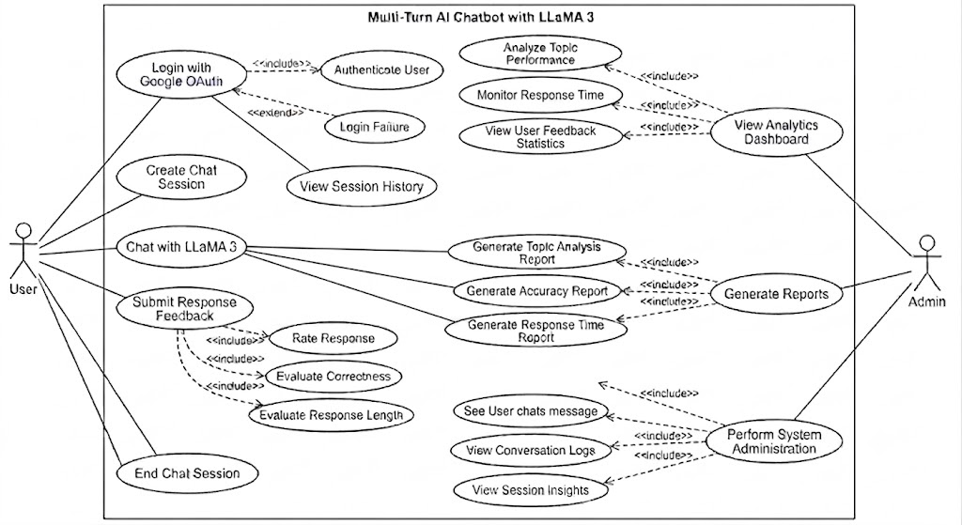

Usage Scenarios:

Use Case Specifications

Use Case 1: Login with Google OAuth

Field | Details
Use Case Title | Login with Google OAuth
Abbreviated Title | User Login
Use Case Id | UC-01
Actors | User, Admin
Description | This use case allows the user or admin to securely log into the system using their Google account via OAuth 2.0.
Pre Conditions | User must have a valid Google account.
Task Sequence | 1. User clicks the "Login with Google" button.  2. System redirects to the Google OAuth authentication page.  3. User authenticates and grants permission.  4. System creates or retrieves the user profile and grants access.
Post Conditions | User is successfully logged in and redirected to the chat interface or dashboard.
Author: Project ID | BC230201330

Use Case 2: Create Chat Session
Field | Details
Use Case Title | Create Chat Session
Abbreviated Title | New Session
Use Case Id | UC-02
Actors | User
Description | This use case initializes a new, independent multi-turn conversation session for the user.
Pre Conditions | User must be logged into the system.
Task Sequence | 1. User selects the option to start a new chat.  2. System generates a unique session ID.  3. System opens a fresh chat interface ready for input.
Post Conditions | A new chat session is active and ready to process queries.
Author: Project ID | BC230201330

Use Case 3: Chat with LLaMA 3

Field | Details
Use Case Title | Chat with LLaMA 3
Abbreviated Title | AI Chat
Use Case Id | UC-03
Actors | User, System
Description | This use case handles the core interaction where the user sends a query and the local LLaMA 3 model generates a response in real time.
Pre Conditions | An active chat session must exist.
Task Sequence | 1. User enters a query and clicks send.  2. System records the timestamp and routes the message to the LLaMA 3 model.  3. System dynamically manages the context window and generates a real-time response.  4. System displays the response to the user.
Post Conditions | The AI response is displayed, and the chat input is temporarily frozen pending feedback.
Author: Project ID | BC230201330

Use Case 4: Submit Response Feedback

Field | Details
Use Case Title | Submit Response Feedback
Abbreviated Title | User Feedback
Use Case Id | UC-04
Actors | User
Description | This use case forces the user to evaluate the chatbot's response before continuing the conversation.
Pre Conditions | Chatbot must have generated a response and the chat input field must be blocked.
Task Sequence | 1. User reviews the feedback panel.  2. User selects a Rating (1-4), Correctness level, and Length type.  3. User submits the feedback.  4. System unblocks the chat input for the next message.
Post Conditions | Feedback is recorded in the database and conversation can resume.
Author: Project ID | BC230201330

Use Case 5: End Chat Session

Field | Details
Use Case Title | End Chat Session
Abbreviated Title | Terminate Session
Use Case Id | UC-05
Actors | User, System
Description | This use case allows the user to securely terminate the current multi-turn conversation session.
Pre Conditions | An active chat session must exist.
Task Sequence | 1. User selects the "End Chat" option.  2. System finalizes the session context.  3. System permanently saves the final session analytics to the database.
Post Conditions | The chat session is closed and saved successfully.
Author: Project ID | BC230201330

Use Case 6: Real-Time Data Storage

Field | Details
Use Case Title | Real-Time Data Storage
Abbreviated Title | Store Data
Use Case Id | UC-06
Actors | System
Description | This use case automatically stores every user message, AI response, and feedback entry into the database in real time.
Pre Conditions | A chat transaction or feedback submission must occur.
Task Sequence | 1. System detects a new message or feedback entry.  2. System attaches the session ID, timestamp, and predicted topic label.  3. System writes the record to the database.
Post Conditions | All interaction data is securely saved for future analytical use.
Author: Project ID | BC230201330

Use Case 7: Generate Analytics Reports

Field | Details
Use Case Title | Generate Analytics Reports
Abbreviated Title | Generate Reports
Use Case Id | UC-07
Actors | System, Admin
Description | This use case involves computing core metrics like response accuracy, topic performance, and session phase data to create structured reports.
Pre Conditions | Interaction data must exist in the database.
Task Sequence | 1. System fetches chat logs and feedback data.  2. System calculates response times, correctness percentages, and rating averages.  3. System formats this data into interactive tables and visual graphs.
Post Conditions | Comprehensive analytical reports are generated and ready for display.
Author: Project ID | BC230201330

Use Case 8: View Analytics Dashboard

Field | Details
Use Case Title | View Analytics Dashboard
Abbreviated Title | View Dashboard
Use Case Id | UC-08
Actors | Admin
Description | This use case allows the admin to visually monitor the performance and behavioral metrics of the chatbot via a graphical dashboard.
Pre Conditions | Admin must be logged in and reports must be generated.
Task Sequence | 1. Admin navigates to the Analytics Dashboard page.  2. System loads pie charts, bar charts, line graphs, and summary tables.  3. Admin reviews topic-wise accuracy, session insights, and user feedback statistics.
Post Conditions | System performance metrics are displayed successfully.
Author: Project ID | BC230201330

Use Case 9: Perform System Administration

Field | Details
Use Case Title | Perform System Administration
Abbreviated Title | System Admin
Use Case Id | UC-09
Actors | Admin
Description | This use case allows the admin to monitor and review raw conversation logs and system insights for quality assurance purposes.
Pre Conditions | Admin must have elevated system privileges.
Task Sequence | 1. Admin selects the administrative panel.  2. Admin filters and selects specific user sessions to view chat messages.  3. System displays the raw conversation logs and deep session insights.
Post Conditions | Admin successfully audits system logs and user conversations.
Author: Project ID | BC230201330

Use Case 10: View Session History

Field | Details
Use Case Title | View Session History
Abbreviated Title | Session History
Use Case Id | UC-10
Actors | User
Description | This use case allows the user to access and review their previously completed chat sessions and conversation history stored in the system.
Pre Conditions | User must be logged in and must have at least one previously completed chat session.
Task Sequence | 1. User navigates to the Session History section.  2. System retrieves all past sessions associated with the user account.  3. User selects a specific session from the list.  4. System displays the full conversation log, timestamps, and feedback records for the selected session.
Post Conditions | User successfully views past conversation history and associated feedback records.
Author: Project ID | BC230201330

Use Case 11: Topic Classification

Field | Details
Use Case Title | Topic Classification
Abbreviated Title | Classify Topic
Use Case Id | UC-11
Actors | System
Description | This use case enables the system to automatically classify each user message into a predefined domain topic such as Machine Learning, Healthcare, Power Systems, Deep Learning, or E-commerce using a classification model.
Pre Conditions | A user message must be received by the backend system.
Task Sequence | 1. System receives the user message from the frontend.  2. System passes the message to the topic classification module.  3. Classification model assigns a domain label (e.g., Machine Learning, Healthcare).  4. System attaches the topic label to the message record before storing it in the database.
Post Conditions | Each user message is tagged with a topic label and stored for analytics processing.
Author: Project ID | BC230201330

Use Case 12: Context Window Management

Field | Details
Use Case Title | Context Window Management
Abbreviated Title | Manage Context
Use Case Id | UC-12
Actors | System
Description | This use case describes how the system monitors topic changes during a conversation and dynamically adjusts the context window passed to the LLaMA 3 model to maintain response relevance and avoid context overflow.
Pre Conditions | An active multi-turn chat session must exist with at least one prior exchange.
Task Sequence | 1. User submits a new query during an active session.  2. System compares the current query topic with previous conversation topics.  3. If a topic shift is detected, system resets or trims the context window accordingly.  4. System passes the updated context along with the new query to the LLaMA 3 model.  5. Model generates a contextually relevant response.
Post Conditions | LLaMA 3 receives a properly managed context window, producing more accurate and relevant responses.
Author: Project ID | BC230201330

Use Case 13: Response Time Tracking

Field | Details
Use Case Title | Response Time Tracking
Abbreviated Title | Track Response Time
Use Case Id | UC-13
Actors | System
Description | This use case describes the process by which the system automatically calculates and records the time taken by the LLaMA 3 model to generate a response for each user query.
Pre Conditions | A user query must have been submitted and a response must have been generated by the model.
Task Sequence | 1. System records the timestamp when the user submits a query (request time).  2. System records the timestamp when the model completes response generation (response time).  3. System calculates response time as the difference between the two timestamps.  4. System stores the calculated response time alongside the message record in the database.
Post Conditions | Response time is accurately recorded per message and made available for analytics and performance reporting.
Author: Project ID | BC230201330

Use Case 14: Analyze Topic Performance

Field | Details
Use Case Title | Analyze Topic Performance
Abbreviated Title | Topic Analysis
Use Case Id | UC-14
Actors | System, Admin
Description | This use case describes how the system computes and visualizes topic-wise chatbot performance metrics, including accuracy rates, user ratings, and correctness distribution per domain.
Pre Conditions | Sufficient conversation data with topic labels and feedback records must exist in the database.
Task Sequence | 1. Admin triggers the topic performance analysis from the analytics module.  2. System retrieves all messages with associated topic labels and feedback records.  3. System groups data by domain (e.g., ML, Healthcare, E-commerce).  4. System computes accuracy, average rating, and correctness percentages per topic.  5. System generates bar charts, pie charts, and summary tables for topic-wise performance.  6. Results are displayed on the analytics dashboard.
Post Conditions | Topic-wise performance metrics are computed and displayed as interactive visual reports on the dashboard.
Author: Project ID | BC230201330

Use Case 15: Login Failure Handling

Field | Details
Use Case Title | Login Failure Handling
Abbreviated Title | Login Failure
Use Case Id | UC-15
Actors | User, System
Description | This use case describes how the system handles authentication failures during the Google OAuth login process, including scenarios where the user denies permission, the session expires, or a network error occurs.
Pre Conditions | User must have attempted to log in via Google OAuth.
Task Sequence | 1. User clicks the "Login with Google" button and is redirected to the Google OAuth page.  2. User denies permission, closes the popup, or an authentication error occurs.  3. Google OAuth returns an error or cancellation response to the system.  4. System intercepts the failure response and prevents any session creation.  5. System displays a clear error message on the login page (e.g., "Authentication failed. Please try again.").  6. User is given the option to retry the login process.
Post Conditions | No session is created, user data is not stored, and the user is safely returned to the login page with an appropriate error message.
Author: Project ID | BC230201330

Adopted Methodology
For the development of the Library Management System, the VU Process Model has been adopted. The VU Process Model is a hybrid software development methodology that combines the features of both the Waterfall Model and the Spiral Model. This methodology provides the advantages of a structured and sequential development process while also supporting iterative improvement and risk handling. It is suitable for academic software projects because it ensures proper documentation, organized development phases, and continuous refinement of the system.
The Waterfall Model contributes a step-by-step development approach where each phase is completed before moving to the next phase. On the other hand, the Spiral Model adds flexibility by allowing repeated evaluation, testing, and improvement during development. By combining these two models, the VU Process Model helps in developing reliable, efficient, and user-oriented software systems.
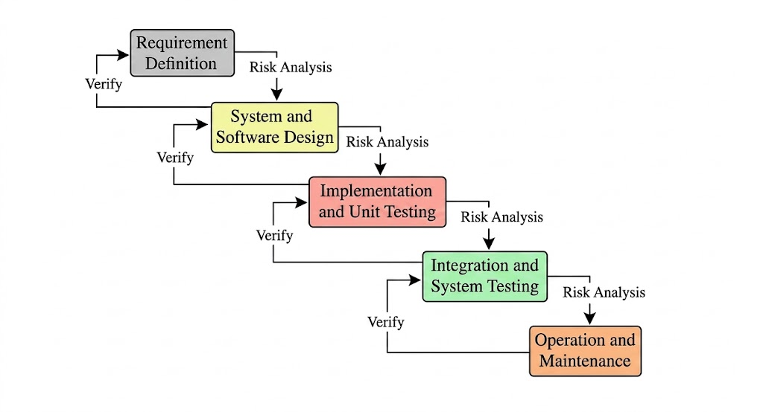

Waterfall Model
The Waterfall Model is a traditional software development methodology in which the development process follows a linear and sequential flow. In this model, each phase must be completed before the next phase begins, and there is no overlap between stages. The process starts with requirement analysis, where all system requirements are collected and documented. After that, system design is prepared, which defines the architecture, database structure, and interface layout. The next stage is implementation, where the actual coding of the system is done according to the design. Once development is completed, the system is tested to identify and fix errors. After successful testing, the system is deployed for use, and finally, maintenance is performed to handle updates and issues. The Waterfall Model is simple, easy to understand, and well-structured, but it is less flexible because changes are difficult to implement once a phase is completed. It is suitable for small and clearly defined projects.
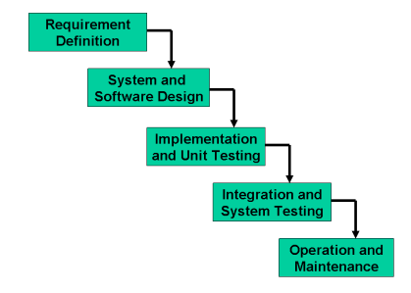

Spiral Model
The Spiral Model is a risk-driven and iterative software development methodology that combines elements of both prototyping and systematic development. In this model, the system is developed in repeated cycles called spirals, where each cycle improves and enhances the system based on feedback and evaluation. Each spiral consists of four main activities: planning, risk analysis, engineering, and evaluation. In the planning phase, requirements and objectives are defined. During risk analysis, potential risks are identified and solutions are planned to minimize them. In the engineering phase, the system is designed, coded, and tested in parts. In the evaluation phase, users review the system and provide feedback for further improvement. The Spiral Model is highly flexible and allows continuous refinement, making it suitable for large and complex projects. It provides strong risk management and better quality control, but it is more complex and expensive compared to other models.
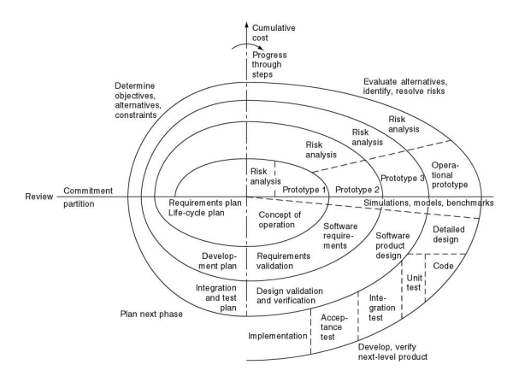

Reasons to Choose VU Process Model
- Combination of Waterfall and Spiral Models
The VU Process Model is selected because it integrates the structured nature of the Waterfall Model with the iterative and flexible nature of the Spiral Model. This combination helps in maintaining proper discipline in development while also allowing improvements at different stages of the project.
- Clear and Well-Organized Development Process
This model provides a step-by-step structured approach where each phase is completed before moving to the next. It helps in clearly understanding requirements, designing the system properly, and implementing it in an organized way, which reduces confusion during development.
- Continuous Improvement Through Iterations
The VU Process Model supports repeated evaluation and refinement of the system. After each phase, feedback can be used to improve the system, which ensures that the final product is more accurate, efficient, and closer to user requirements.
- Early Detection of Errors and Risk Management
Since testing and evaluation are performed throughout the development process, errors and risks are identified at an early stage. This reduces the chances of major problems in the final system and improves overall software quality and reliability.
- Better Documentation and Project Control
Every phase of the VU Process Model is properly documented, which makes it easier to track progress and manage the project. This documentation also helps in future maintenance and upgrades, ensuring that the system can be improved or modified when required.

Work Plan (Use MS Project to create Schedule/Work Plan)

